### General Company Description

**Mission Statement**: Alexandria Brewing Company will build a legacy focused on honesty and quality of which its investors and the City of Alexandria can be proud. We will champion the creative spirit and use it to be an industry leader in Kentucky and the Greater Cincinnati Area.

**Company Goals and Objectives:** Alexandria Brewing Company will become the preferred manufacturer of high quality craft beer in the Greater Cincinnati Area and will focus on innovative brewing techniques, unique beer recipes, and challenging the guidelines set forth by the BJCP (Beer Judge Certification Program). In doing so, Alexandria Brewing Company will offer a selection of flagship beers available all year as well as several seasonal offerings and other limited release beers. These beers will be sold at an on premise taproom as well as through local distribution in kegs, cans and/or bottles in Greater Cincinnati Area.

**Business Philosophy:** “If it isn’t safe or if it’s questionable to put in one’s body, it won’t go into our beer.” Alexandria Brewing Company will brew unique, high quality ales and lagers in a traditional, non-additive manner. We are a community-based business that operates ethically and environmentally friendly

**Legal Form of Ownership**: Alexandria Brewing Company will be a Limited Liability Corporation (LLC) which will file taxes as an S corporation. The top five (5) shareholders will form a Board of Trustees to act in the best interest of all the shareholders. Refer to the *Alexandria Brewing Company Operating Agreement* for additional details of the daily operations and employee hierarchy. Alexandria Brewing Company may operate with additional companies (also LLCs) to lease the land and equipment to the brewery. The additional companies have yet to be established at this time.

### Products and Services

Alexandria Brewing Company will offer a selection of flagship beers available all year at the taproom and through distribution. It will also offer several seasonal offerings and other limited release beers that will rotate. The seasonal offerings will have scheduled availability once during the year, but the other limited release and/or experimental releases may only be a one-time offering at the taproom.

**Flagship Beers**

At the taproom and beer garden, the brewery plans to do line level pricing of $5/pour for the flagship beers at the time of opening.

* **Cecilia’s Grace** – A Trapist-style Quadrupel with bold dark fruit notes and a deep level of complexity. Currently, there is not a brewery in the Cincinnati area that has a Belgian Quad in their regular rotation. This is a favorite style for those who are new to craft beer and for those who consider themselves experts on craft beer. In short, it is a crowd pleaser. The downside is that it is expensive to make and takes the most time in the fermenter. However, the CFO has balanced these considerations to make it a profitable beer for the brewery. This will be sold as a half pint pour in the taproom.
* **Ann’s Sweet White Ale** – A stronger, sweeter take on a Belgian-style wit. It is brewed with orange peel, coriander and wheat. We foresee this as being our most popular beer as it is very approachable and enjoyable, even to those not yet fully indoctrinated into craft beer. Almost every craft brewery has a Wit-style beer in its rotation. However, Alexandria Brewing Company’s version is different due to the use of both bitter and sweet orange peels. It’s also slightly stronger than the average Belgian-style Wit which lends to the sweetness and therefore makes it more appealing to the average consumer. This will be the most profitable beer as required fermentation time is minimal. This will be sold as a full pint pour in the taproom.
* **JWR Tripel** – A Trapist-style Tripel brewed with raisins. This beer is slightly dry and has a high ABV. Like the Quad, it is a style that most breweries only do annually, but only one (Fifty West) has in its regular rotation. This beer is our strongest recipe and has fared really well in a national competition at the Indiana State Fair. The strength and complexity of this beer sets it apart. The addition of raisins accomplishes the design goal of creating a beer that pairs well with red meat and will also make it appealing for wine drinkers to try. Like the Quad, it requires more time in the fermenter which affects profitability, but this beer along with the other seasonal offerings will be what makes Alexandria Brewing Company a destination brewery. This will be sold as a half pint pour in the taproom.
* **All Up In Your Berlinerweiss** – The Berliner Weisse is sometimes referred to as a “gateway” to sour beer. It is slightly more tart, crisp, and refreshing than most people might expect at first. It has a burst of citrus and is very drinkable. There are two breweries in the Cincinnati area that make a Berliner-style beer, River Town and Urban Artifact. Urban Artifact does it well and makes with several variations. Alexandria Brewing Company’s interpretation is more traditional and has a very low ABV, but utilizes an innovative hop bill and dry hop technique unlike the original German Berliner Weisse. This is the second most profitable of the flagship beers and will appeal to the masses. This will be sold as a full pint pour in the taproom.

**Seasonal / Special Releases**

Listed below are the seasonal beers Alexandria Brewing Company will brew as part of the normal rotation. Any other beers will be brewed on the pilot system first, test marketed in the taproom, and then worked into the brewing rotation, if successful.

* **Threshold** – If there was a "regular beer" selection, this is that beer. This is a White IPA (or a WPA) that has the malt profile of a Belgian Wit, but it’s hopped with American hops in a West Coast style. Braxton, Blank Slate, and Fifty West all do an over-hopped wheat beer or White IPA. Alexandria Brewing Company’s interpretation is different due to the malt bill and it’s made like a Belgian-style Wit. It has a very spicy, complex malt backbone that is amplified with the West Coast hops and the dry hopping process. It is really the fusion of two styles of beers not previously combined and should create a positive buzz in the craft beer community. The brewery anticipates selling out of this beer quickly every time it’s brewed. This will be sold as a full pint pour in the taproom.
* **Go Hop Yourself** – A Double India Pale Ale brewed made with honey. This is an easy to drink (too easy!) beer with a well-hidden high ABV. Just about every craft brewery in the world has an American-style Double IPA. Alexandria Brewing Company’s Double IPA is different because of its hop profile and the addition of honey. It is very drinkable despite its high ABV percentage. Bell’s Brewing Hop Slam (one of the most popular Double IPAs in the country) was the design inspiration, but Andy’s goal was to make it better and this beer was the result. This beer is also expected to sell out quickly and will be another one that makes Alexandria Brewing Company a “destination brewery.” This will be sold as a half pint pour in the taproom.
* **Licking River Water** – This is a Black IPA. This style is also popular with all breweries. The malt beer differentiates Alexandria Brewing Company’s version from the competition due to the incredibly smooth mouth feel imparted by the malts used. This characteristic really makes this beer really stand out among the others. This beer is expected to sell rather quickly as well. This will be sold as a full pint pour in the taproom.



##### Location

Alexandria, Kentucky is a rural area in the process of growing and transitioning to more suburban community. Several farms are being sold and converted to subdivisions thus offering people a country lifestyle close to the city. The brewery’s potential customer base will continue to grow as more and more people move to Alexandria. One risk of the location is that local bars, restaurants, and tastes are currently slow in craft beer. The typical restaurant carries one craft beer and six to eight selections of macro beer (e.g. Bud Light, Miller Light, Coors Light). There is one local grocery store, Country Market, selling a large amount of craft beer. This is because the owner, David Kremer, conducted his own research and determined Alexandria is an underutilized market. He is also involved with Bluegrass Liquor in Cold Spring, Kentucky (about 5 miles North from his grocery store and next to Northern Kentucky University). His father, Jerry Kremer, owns that business. David’s market research shows that craft beer is selling better at his store in Alexandria compared to his father’s store in Cold Spring. This partly has to do with Applebee’s and Barleycorn’s being in Cold Spring, but even the craft beer selections at those restaurants are minimal. David attributes the craft beer success at his grocery store to the family age of the patrons in Alexandria and wanting the higher quality product. Right now, Alexandria has only one bar, Hay Loft, which serves craft beer. It is crowed most nights, but it doesn’t fully provide what Alexandria needs – a true family spot. The taproom will be a “bar” but it will also be an experience for the family. There will be vintage arcade and pinball games for the kids, along with cornhole and board games. It will also have an authentic German-style beer garden outside that will have a dog friendly area with water bowls. These features will help make Alexandria Brewing Company an affordable destination for families.

A site assessment survey was done by the American Brewers Guild which surveyed successful bars and brewpub operations. This assessment identified some important site characteristics that were believed to have contributed to the success of the businesses. Alexandria Brewing Company has investigated three potential sites in Alexandria and has determined that the area meets or exceeds the characteristics identified by the American Brewers Guild site assessment:

**Specification Recommendation Alexandria Brewing Company**  
15-mile radius population 150,000 minimum 169,895  
Average per capita income $30,000 minimum $52,233.82 (in radius), $70,175 (Alexandria)  
Percent of population in target age group 50% 64% (28-65, Alexandria)  
Number of successful restaurant s in area 5 or more More than 10  
Number of successful bars in area 3 or more More than 5  
Foot traffic Moderate to Heavy Moderate  
Commerce A must Yes  
Parking Adequate for pm business Ample  
*Proximity to:*  
 Downtown Important Yes  
 Offices Important Yes  
 Sporting facility Asset Yes  
 College Asset Yes (NKU, UC)  
 Tourist attractions Desirable Yes   
Expansion potential Desirable Yes (based on location)  
Aesthetics Moderately important Strong  
Utility requirements Must meet minimums May require some site improvements  
Access Must be uncomplicated Yes  
Neighborhood support Important Yes

Distribution Channels

At first, Alexandria Brewing Company will self-distribute. This will allow the brewery to be more profitable as it grows. We will mainly focus on the Northern Kentucky, Lexington, and Louisville markets. Eventually, we will face the challenge of expanding across the state line into Ohio as that will require distributor. An expansion of brewery production facilities is planned for Phase Two, at which time we plan to work with Cavalier Distributors in order to get our beer distributed in the Cincinnati and Southwest Ohio markets.

Once opened, Alexandria Brewing Company will employ one or two sales representatives to get our beer into restaurants, bars, liquor stores, and bottle shops with growler sales. The sales representatives will have a base salary supplemented by sales commission (TBD). The Chief Operating Officer (COO), Brad Martin, will be responsible for setting sales goals and approving the marketing plan for each week. Until the brewery can support having sales representatives, Brad will be responsible for acquiring new sales and business.

##### Sales Forecast

**Taproom** –The brewery will have 125 interior seats with an additional 100 exterior seats in the beer garden. The beer garden will operate from mid-March to mid-November, depending on the weather. The taproom will be open Thursday through Monday, 4:00 pm to 1:00 am, with hours adjusted based on demand. Mondays are expected to be the slower day, but we hope to draw the service industry employees as most high end restaurants, bars, bottle shops, and other breweries are closed on Mondays. This gives those employees a place to gather and enjoy craft beer.

**Keg Sales** – Based on research we have done with others in the industry, we expect to be able to move the majority of our excess production capacity in the form of keg sales. A survey of industry sources found that many craft breweries with systems similar to ours sell 60% or more of their capacity via keg sales. We do expect keg sales to start more slowly but once word of the brewery and taproom spreads, keg sales will grow. We have select retailers ready to carry our beer at launch (e.g. D.E.P.s Ft. Thomas, Kentucky and Bluegrass Liquor), but growing our distribution footprint will be the major focus of our director of sales & marketing. For year one, we are setting a goal of 1500 barrels sold via kegs.

##### Production

Our head brewer, Andy Reynolds, will oversee all production. He will work with the CFO (Brian), and COO (Brad) to determine demand and set a brewing rotation based on that demand.

Raw materials will be determined by Andy and ordered by the COO (Brad) from suppliers. Brad is responsible for obtaining and maintaining all of the “hop contracts” required for select strains of hops.

Production will occur on the brewery’s DME 15 BBL brewhouse. This system was chosen by Andy after months of research. After each 15 barrel (BBL) batch is produced, it will be sent to one of the four 30 BBL fermentation tanks to begin the fermentation process. Each tank will take two 15 BBL batches to fill, making a “brew day” a filling of one fermentation tank. Andy will check the quality of the beer while it is fermenting, dumping excess trub and ensuring that fermentation is occurring properly. Once fermentation is complete, the tank will be transferred to the bright tank (tax determination vessel) to carbonate. Once carbonated and deemed “clear” by Quality Assurance (Brad), the beer will be kegged and labeled. From there, it will be stored until it is ready to go to the taproom’s refrigeration or to the distribution lot.

Product development will be controlled by Andy Reynolds via the ½ BBL (15.5 gallon) pilot system. The beer brewed on this system is to prove a new recipe and determine profitability. Once brewed, it will be fermented in a small homebrew-style conical fermenter. When ready, it will be kegged, tested by Quality Assurance and test marketed as a limited release in the taproom. If a demand justifies it, it will be scaled for production and added into the brewing rotation.

##### Location

The two most important factors Alexandria Brewing Company needs to consider for selecting a location are ease of access for deliveries (raw materials) and size (either big enough to support a new building or with a building big enough to support brewing operations and a taproom).

Physical Requirements:

* 4000 - 6000 sq. ft.
* Steel Building or Pole Barn
* Water, sewage, gas, and power are other key physical requirements that need to be met.

A detailed estimate on operational costs as well as a conceptual building plan/design are contained in the attached financial summary.

The business hours will be different for the brewery and the taproom, though they may overlap. The brewery will operate Monday through Friday, 8:00 am to 6:00 pm. Based on brewing demands, a weekend day may be required. The taproom will operate Thursday through Monday, 4:00 pm to 1:00 am. This will be subject to change based on demand.

##### Legal Environment

Alexandria Brewing Company will require federal bonding of $100,000 which costs approximately $100/month. This is the required federal licensing to brew beer. In addition, a microbrewery license is required by the Commonwealth of Kentucky and will cost $500/year. These two licenses are necessary for Alexandria Brewing Company to be a legal brewery.

A brewery is considered to be a manufacturing facility and we will therefore be required to meet all of the OSHA requirements under their manufacturing guidelines. It will fall under the responsibility of the COO (Brad) to ensure that these requirements are being met. The brewery must also be FDA compliant for food service requirements. The COO will also ensure the brewery and the taproom are meeting all FDA regulations. Finally, the brewery is accountable to the TTB for reporting and paying production taxes to the federal government. It will be the responsibility of the Head Brewer (Andy) to ensure accurate records are kept for the materials used and the production received from those materials as this has to be reported to the TTB. It will be the CFO’s (Brian) responsibility to ensure that the $7 per barrel tax is being satisfied to the TTB. Also, TTB oversight includs label filing. This responsibility will fall onto our graphic designer, Anthony Nguyen. The filing of our labels will also include the filing of federal trademarks. Anthony will research any names used and ensure we are not violating any trademarks or copyrights that may exist.

##### Personnel

Alexandria Brewing Company will initially operate with a small number of people with the following roles:

1. Mark A. (Andy) Reynolds – President, Head Brewer, and Board Member
2. Brian Fish – Chief Financial Officer (CFO)
3. Brad Martin – Chief Operating Officer (COO)
4. Joseph M. Reynolds – Yeast Management and Lab Technician (under QA)

Other positions required, such as bartenders, will be filled by volunteers and family members until the brewery can justify hiring for these positions. The justification of such a matter will fall on the COO and must be approved by the CFO. The hiring of all of these positions will initially be the responsibility of the COO until he recommends the hiring of a Taproom Manager and approved by the CFO before being officially approved by the Board. Brewery positions, such as assistant brewer and brewer, will be determined necessary by the Head Brewer. The hirings must be approved by the CFO.

Essentially, any hourly position is left to the determination of the COO and/or the Head Brewer and approved by the CFO. Any salaried position is requested by the COO and/or the Head Brewer, approved initially by the CFO and presented to the Board for final approval.

Facilities work, such as cleaning duties and repairs, will be contracted to third parties. It is the responsibility of the COO to evaluate and source vendors for the necessary services. These contracts must be approved by the CFO before put into place.

Please see the attached financial sheet for proposed starting salaries.

##### Inventory

**Raw Material Inventory** – Raw material inventory will be ordered on a weekly basis based on the brewing schedule. We plan to order supersacks of grain from the supplier most able to fulfill the grain bill requirements for a particular beer. What cannot by purchased by supersack will be order in quantities of the industry standard of a fifty pound sack. This grain will be stored the “storage” area of our building. Hops will most likely need to be ordered on an annual or semi-annual basis (industry standard) based on hop contracts and will be stored in the brewery’s walk-in freezer.

**Finished Goods Inventory** – Finished goods (kegs) will be stored in the “walk-in refrigerator” area of our building.

**Average Value of Inventory in Stock and in Production** – Inventory in production will be calculated as the cost of raw materials until it is transferred into the bright tank at which point it becomes realized inventory. The estimated value of work in progress inventory at any given time will be $7,400. The value of stockpiled completed inventory on hand at any given time will be $140,000.

Managing all accounts payable and accounts receivable will be the responsibility of the COO using a spreadsheet developed by the CFO. The CFO will review and audit our accounts quarterly to ensure all monies are flowing properly.

### Management and Organization

Alexandria Brewing Company will be run by a Board of Directors comprised of the top five shareholders. However, the day to day operations will be handled by the COO, CFO and Head Brewer. Essentially, the COO is responsible for running the business side of the brewery while the Head Brewer is responsible for running the production side. The CFO acts as a check and balance as his role is to approve any proposed projects by either the COO or the Head Brewer. The Head of Sales and Marketing will be responsible for keg sales until a sales representative position is established. He will also be responsible for validating that beer names have been registered and trademarked by the Graphic Designer. The Head of Sales and Marketing will also be responsible for researching the competition and ensuring the brewery maintains competitive pricing.



Please see the Operational Contract attached for details of day to day operations.

##### Key Position Employee Resumes

The following key position employees:

* Mark Andrew (Andy) Reynolds, President, Head Brewer, and Board Member
* Brian Fish, CFO
* Brad Martin, COO
* Joseph Michael Reynolds, Lab Manager

### Startup Expenses and Capitalization

Alexandria Brewing Company will establish an additional one or two LLCs to act as holding companies for the land/building and equipment operated by the brewery. This is necessary to protect the brewery in the unlikely event of a lawsuit. The brewery will lease the assets from the respective holding company (ies). Dividends will be paid from earnings from all companies.

##### Location and Building

Alexandria Brewing Company has budgeted $325,000 for land acquisition and $300,000 for building construction. This is a maximum budget. If a property becomes available that has an existing steel building/pole barn that meets the requirements for the brewery, then we will be able to reduce this amount. The obvious choice is to move into an existing structure, but they seem to be in short supply at this time in the Alexandria and Cold Spring, Kentucky areas. It should be noted that this budget does include all interior and exterior fixtures (e.g. furniture, bar, taps, etc.).

##### Brewing Equipment

Alexandria Brewing Company has selected DME (Diversified Metal Engineering) to provide a 15 barrel (BBL) brewhouse with four 30 BBL tanks and one to two 30 BBL bright tank. Please see the appendices for a complete description. The estimate for the equipment and installation is $316,684.81. Currently, there is approximately a 20 week lead time to produce the equipment. The installation time will depend on the status of our building.

##### Other Required Items

**Kegs** – Alexandria Brewing Company will require approximately 1200 stainless steel Sankey kegs. The cost of a new keg is currently $65-$350, depending on the manufacturer and the quantity ordered (i.e. bulk discounts). We are still shopping suppliers as the goal is get the best quality kegs for the best price.

**Chemicals** – Alexandria Brewing Company will require sanitizer, caustic cleaner, non-caustic cleaner and acid cleaners. At this time, all of this will likely be provided by 5 Star Chemicals. The costs for these chemicals will be included in our monthly budget, but it should be noted that these chemicals will be ordered in a high quantity at start-up in order to have enough on-hand for production ramp-up.

**Forklift** – At startup, Alexandria Brewing Company will purchase a forklift, preferably used, to assist with receiving of and movement of the large amounts of grains required in the brewing of our beers and the materials used to support the production operations.

### Financial Plan

The plan is for Alexandria Brewing Company to open on 10/01/2016 (Financial Year 2016). Up until that point, there will be no income and the brewery will be in a construction phase. Below is the financial plan created by the CFO, Brian Fish. Please see the appendices for the entire projected financial summary.

##### Five-Year Profit Projection

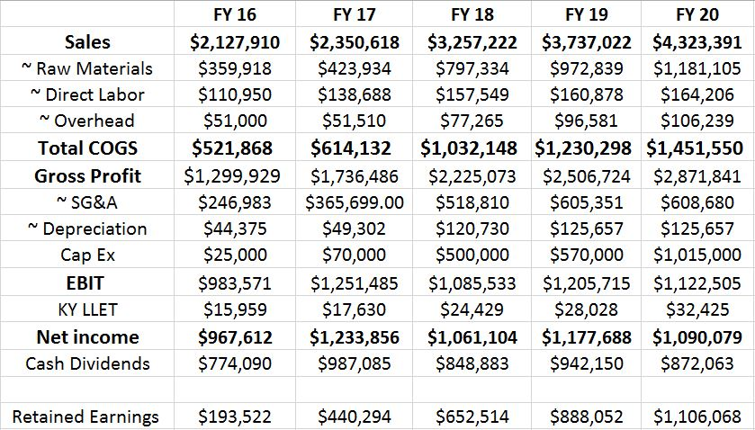

A fiscal year is October to September but that may change to calendar year according to business need. Please note the that we anticipate strong sales of our products for the period labeled FY 16, which denotes October 2016 through September 2017. The sales forecast was done by taking the average sales price multiplied by the anticipated sales for taproom, growler fills, and kegs that were specified earlier.

Raw materials were costed as an average of the six current Alexandria Brewing Company beers. We do expect this to change both from demand and from an expansion of our product line. The production cost includes the raw materials as well as the water necessary water for both production and sanitation. Per GAAP, we have included direct labor in the projection of cost of goods sold, with the remainder of labor being costed in sales, general, and administrative expenses. At this time, the only overhead costs are utilities, cleaning chemicals used in the production of our product, and the operation of our taproom.

Depreciation and Kentucky limited liability entity pass through tax were calculated as proscribed by both the State of Kentucky and the Internal Revenue Code. Per GAAP, we will depreciate all assets used in the business with a straight-line schedule appropriate to the type of property, plant and equipment.

In addition to the amount we have set aside for retained earnings, we have scheduled capital expenditures to promote the expansion of the business. The retained earnings will be used for liquidity during the expansion and the capital expenditures will be used directly towards additional property, plant and equipment.

With these understandings, we project the business to have strong net income from inception through the first five years. We project almost $1 million in net income in our first year with net income being no less than $1 million in any year thereafter. While these figures are estimates and can change based on commodity costs and costs of equipment, we expect strong demand and taproom sales which are the key revenue drivers for our brand.

##### Projected Cash Flow

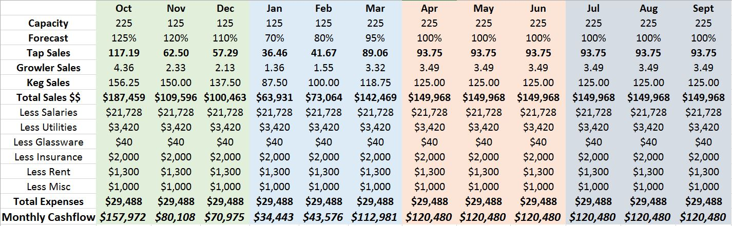

Cash Flows

We project strong cash flows throughout FY 2016 with October being our strongest month due to a number of factors, including novelty, increased startup advertising, product supply, and climate.

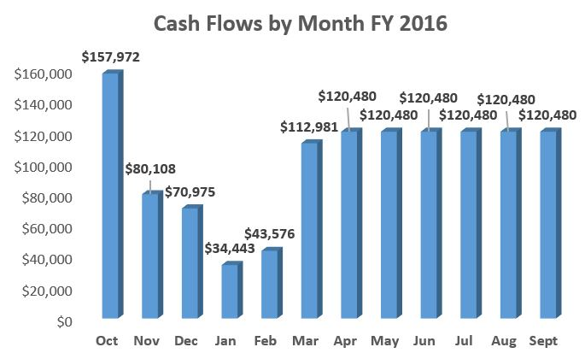

Capacity

As we have previously stated, we will be operating a taproom with an attached beer garden for combined total capacity of 225 seats. Since the taproom is located in a climate where we expect sub-freezing temperatures in the winter months, the beer garden will not be open November through February. We anticipate that climate will allow outdoor seating in relative comfort for 8 months out of the year, giving us an average capacity of 192 seats.

Taproom Sales

We have calculated taproom sales based on margin using a weighted average calculation of what we expect our sales mix to be. We expect the largest volume sellers to be JWR Trippel, Ann’s Sweet White Ale, and Threshold IPA. These beers will account for 60% of our sales with the remainder coming from our other three launch beers.

Our annual forecast is based on the average of five barrels sold per seat in our taproom. While 6-8 is the commonly used average, we are conservatively forecasting five to start with a compound annual growth rate of 4% to match industry standard in following years. We then adjusted the average forecast for a normal business lifecycle and to account for the different seat capacities by month in the taproom.

Expenses

Our major monthly expenses include staff salaries, insurance, rent, utilities, miscellaneous supplies, and glassware breakage. We have calculated our utilities cost using the industry average of 95 KwH per square foot annually for a total of $41,040 for our 4,800 square foot facility. This number will fluctuate by season, but the exact variance will be difficult to forecast at this time due to not yet having a building. Monthly rent will be paid to the holding company that owns the land, brewing equipment, and building in the amount of $1,300. Miscellaneous supplies will include items such as cleaning and sanitizing chemicals for the brewery and taproom as well as general office supplies. Lastly, we anticipate around $40/month in broken glassware. While we will have a large number of glasses in the taproom, $40/month represents an amount slightly over the industry average of 5% breakage per month.

Key Takeaways

Accounting for salaries, the monthly cash flow forecast still indicates a healthy cash flow. It is important to note that tax, water, spillage, and raw materials have already been accounted for because the cash flows are based on batch margins. While there is some seasonality in the forecast due to reduced capacity for winter months, we are still able to generate positive cash flow in every month and there is plenty of room for growth in the model.

Break-Even Analysis

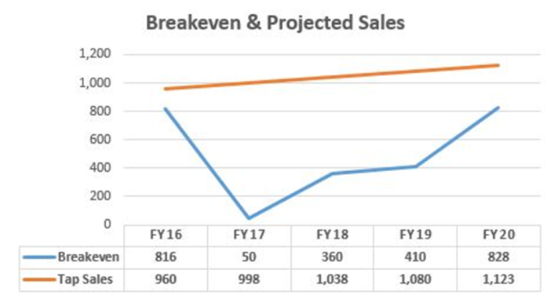

The breakeven point is calculated as the average margin from tap sales (defined as sales revenue/variable manufacturing costs) per barrel divided by various expenditures. It is important to note that these numbers are based only on taproom sales, which are project to be the highest revenue source. The breakeven point of roughly 816 barrels in our first fiscal year represents taproom sales of less than four barrels per seat in our taproom. Subsequent years have a much larger spread between the breakeven and anticipated taproom sales.

### Dividends/Retained Earnings

##### Retained Earnings

Retained earnings are funds taken from the net income (earnings after all expenses have been paid) and set aside for repairs and future growth of the brewery. Alexandria Brewing Company will retain 20% of all earnings in order to ensure all repairs can be covered and all phases of growth are met, when needed.

##### Dividends

Dividends are payments made on a per share basis to shareholders as a payment for their investment. They are not guaranteed as they are based on the net income of the business. Alexandria Brewing Company will pay its investors dividends based upon net income to the brewery and to any holding companies established for the breweries property. Dividends will be paid in the following manor: Net income will be totaled at the end of each month. If the breakeven threshold has been met, 20% of the net income will be put in the Retained Earnings Fund. The total left will be put in a Dividend Cash Fund. Quarterly, the amount in Dividend Cash Fund will be paid out according to ownership stake in the company.

##### Board of Directors

The Board of Directors will be comprised of the top five (5) shareholders with the President, Mark Andrew (Andy) Reynolds, acting as Chair of the Board. The purpose of the Board is to represent the shareholders and ensure that the company is following the goals set forth in this business plan. Each vote will be equal in the board meetings, regardless of the number of shares held by each board member.

The Board is unable to vote on sale of the brewery and creative control of the brewery as these two issues will always remain under the control of the Founder and President, Mark Andrew (Andy) Reynolds.

### Growth Plan

Alexandria Brewing Company has laid out the plans for expansion based on the success and failure of other Greater Cincinnati area breweries. We have learned from them what has worked for them and what hasn’t worked for them and have incorporated the budget for the expansion phases in our financials. The board will have the ultimate decision on when it is time to expand and approve the plans to expand.

##### Phase I

Phase I is the initial construction of Alexandria Brewing Company, including: purchasing of the land, building or remodeling of a building, installing the brewhouse and fermenter tanks, building a taproom and building a beer garden.

##### Phase II

Phase II of Alexandria Brewing Company will be the expansion of our production capabilities. This will involve the purchase and installation of two to four 60 barrel fermenter tanks and one 60 barrel bright tank. Two of these tanks will double our production and we anticipate expanding into Ohio at this point. This will occur within the second fiscal year of operation. We anticipate using a mobile canning operation towards the end of this year to take Ann’s Sweet White Ale, Threshold IPA, and All Up In Your Berlinerwiess in select stores.

##### Phase III

Phase III of Alexandria Brewing Company will be the addition of a canning line and a Belgian-style bottling line (i.e. cork and cage). This is a massive expansion for the brewery which may cause the brewery to take on large debt for the first time. This will allow Alexandria Brewing Company to can or bottle our entire product line and enable them to be sold in all stores that sell craft beer in the Cincinnati, Louisville, Lexington, and possibly Indianapolis markets. We anticipate this occurring towards the end of the third fiscal year.

##### Phase IV

Phase IV of Alexandria Brewing Company will involve an expansion of the brewhouse and buying a bigger system. At this point, we would seek out a 35 barrel 4 vessel system in order to up our production capabilities dramatically. This expansion is extensive and would need to be driven by demand as it would also require more fermenter tanks. We anticipate the need in the fifth fiscal, but only if significant demand requires it. Otherwise, Phase IV would be scaled back to only by the installation of exterior grain silos for base malts. This addition would enable lower production cost as the brewery would order in greater quantities for the two most common base malts and would also require less grain storage area the brewery. The grain silo expansion is anticipated in the fourth fiscal year regardless of whether the brewhouse expansion would occur in the following year.

##### Phase V

Phase V of Alexandria Brewing Company could include the installation if the larger 35 barrel 4 vessel brewhouse, if it was not completed in the Phase IV expansion. It will be the building of a brewpub to replace the taproom. A brewpub would enable us to serve food from our own restaurant. It is yet to be determined if the brewpub would be operated under a new LLC or if the service would be contracted and the space leased. This expansion is anticipated by the seventh fiscal year, but could occur sooner if there is enough demand.